Title (Sentence case)……………………………..
Author1,ª Author2,^{b} Author3^{c,}* (Times New Roman 10 pt; underline the presenter’s name; use (full) Firstname Lastname format)
ªAffiliation of 1st author (Times New Roman 10 pt, include country name)
^{b}Affiliation of 2nd author
^{c}Affiliation of 3rd author (Combine the affiliations that are shared by more than one authors, Do not use number if all authors share the same affiliation.)
*e-mail: e-mail address of the corresponding author

Abstract
Abstract must be concise (must not exceed 250 words) and informative abstract includes:
Importance of the work: Explain in brief of how importance is your research. What is a research gap? What exactly a research question? (not more than 20 words)
Objectives: State the objectives of the research (not more than 20 words)
Materials & Methods: Explain only important information about materials and methods to enable the reader understand the approach used for answering your research question(s). (not more than 50 words)
Results: Present the results according to the objective(s) include important numerical data. (not more than 120 words)
Main finding: Give a conclusion of main finding of the work and point out what is new and/or how does the finding contribute to advancement of the field or how does the finding be applied. (not more than 40 words)

Keywords: (Alphabetically order)
……………, ……………, ……………, ……………, ……………...

Introduction

State the objectives of the work and provide an adequate background, avoiding a detailed literature survey or a summary of the results.

Materials and Methods

Provide sufficient detail to allow the work to be reproduced. Methods already published should be indicated by a reference: only relevant modifications should be described. Research using human, animal and biosafety subjects must include required ethics statements in this section.

Ethics statements (Section heading)

Example 1 (Sub-section heading)
Human/Animal care or biosafety and all experimental procedures were approved by the Human/Animal Experiment Committee, Biosafety Committee _______ University (Approval no._______)

Example 2 (Sub-section heading)
This study was approved by the ethics committee of _______ University (Approval no._______)

Results (or Results and Discussion)

Results should be clear and concise. In text and in the figure caption, “Fig. 1” is used, NOT “Figure 1”

Section heading

Sub-section heading
Sub-section heading
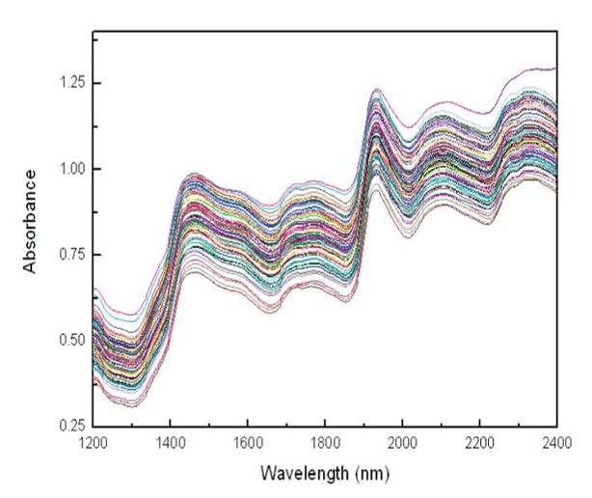

Fig. 1 Original NIR spectra of corn seeds in the wavelength region of 1200-2400 nm.

Table 1 The statistical results of PLS models for determination of oil content in oil corn seeds.
Pretreatments | PC | Calibration |  | Cross-validation
 |  | R_{c} | RMSEC  (%w/w) | R_{cv} | RMSECV  (%w/w) | Bias
Original | 14 | 0.9028 | 0.4995 | 0.8658 | 0.5825 | -0.0065
1st derivative | 14 | 0.9038 | 0.4972 | 0.8714 | 0.5710 | -0.0039
2nd derivative | 8 | 0.8650 | 0.5830 | 0.8436 | 0.6249 | -0.0018
MSC | 14 | 0.9096 | 0.4827 | 0.8723 | 0.5693 | -0.0057
MSC + 1st derivative* | 13 | 0.9045 | 0.4954 | 0.8734 | 0.5667 | -0.0033
MSC + 2nd derivative | 10 | 0.8839 | 0.5432 | 0.8488 | 0.6150 | -0.0050
*the best model

Discussion (or Results and Discussion)

This should explore the significance of the results of the work, not repeat them. A combined Results and Discussion section is often appropriate. Avoid extensive citations and discussion of published literature. The concluding comments should not be a summary of the method and the study as the Abstract provides this. The final paragraph of the paper should identify important outcomes and their implication for the area of study or recommendations for further research. Each reference is identified using parentheses: (Smith et al., 2015). If a reference cited only has two authors, both surnames are listed, e.g. Hawkins and Price (2015) reported that….. If ≥ 3 authors, then: Hawkins et al. (2015) reported that……
No separate Conclusion nor Summary.

Example (Section heading)

Example 1 (Sub-section heading)
Example 2 (Sub-section heading)

Acknowledgments

Collate acknowledgements in a separate section at the end of the article before the references and do not, therefore, include them on the title page, as a footnote to the title or otherwise. List here those individuals who provided help during the research (e.g., providing materials, laboratory equipment, writing assistance or proof reading the article, etc.) and funding.

References (Alphabetical order)

Hodgson, R.W., 1967. The citrus industry. In: Horticultral Varieties of Citrus. University of California Press. Berkeley, CA, USA.
Isnaeni, N.F. 2007. Product formulation of pure instant potatoes [(Ipomoea batatas (L.) Lam] as one of staple food diversification. M.Sc. thesis, Faculty of Agricultural Technology, Bogor Agricultural University. Bogor, Indonesia.
Kurland, L.T. 1970. The epidemiologic characteristics of multiple sclerosis. In: Vinken, P.J., Bruyn, G.W. (Eds.). Handbook of Clinical Neurology, Vol 9: Multiple Sclerosis and Other Demyelinating Diseases. North-Holland Publishing. Amsterdam, the Netherlands.
Liu, C., Peng, D., Yang, Y. 2010. Anti-oxidative and anti-aging activities of collagen hydrolysate. In: Proceeding of 3rd International Conference on Biomedical Engineering and Informatics. Yantai, China, pp. 1981−1985.
Mettam, G.R., Adams, L.B. 1999. How to prepare an electronic version of your article. In: Jones, B.S., Smith, R.Z. (Eds.). Introduction to the Electronic Age. E- Publishing Inc. New York, NY, USA. pp. 281–304.
R Core Team. 2014. R: A language and environment for statistical computing. R Foundation for Statistical Computing. Vienna, Austria. http://www.R-project.org/, 31 December 2014.
Van der Geer, J., Hanraads, J.A.J., Lupton, R.A. 2000. The art of writing a scientific article. J. Sci. Commun. 163: 51–59.

